MTSS Infrastructure and Support Mechanisms
Implementation of multi-tiered system of supports (MTSS) requires appropriate school infrastructure and support mechanisms. By ensuring the proper infrastructure and supports, schools can ensure they have the knowledge, resources, and organizational structures to  - begin MTSS implementation,  - implement MTSS with fidelity, and  - sustain MTSS implementation. | 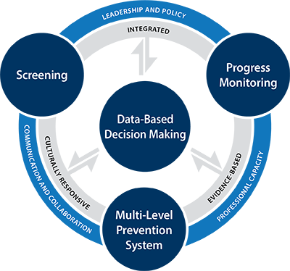

What should you look for?
 | Prevention Focus |  | Leadership Personnel
 | All staff understand that MTSS is a framework to prevent all students, including students with disabilities, from experiencing poor learning outcomes. |  | Decisions by school and district leaders support the components of MTSS at the school and help make it more effective. Support for implementation is a high priority.
 | School-Based Professional Development |  | Cultural and Linguistic Responsiveness
 | School-based professional development is structured so that all teachers examine, reflect on, and improve instructional practice, data-based decision making, and the delivery of interventions and supports. |  | Staff can articulate information and factors that they consider when adopting culturally and linguistically relevant instructional practices, assessments, and intervention programs.
 | Resources |  | Schedules
 | Resources (e.g., funds, programs, staffing) are adequately allocated to support MTSS implementation. |  | Schoolwide schedules support multiple levels of intervention. Adequate additional time is built in for core programming, interventions, and teaming.
 | Communications With and Involvement of Families |  | Communication With and Involvement of All Staff
 | The school ensures that a description of the school’s components of MTSS is shared with families; a coherent mechanism is used to update families on the progress of their child; and families are involved during decision making regarding their child’s progress. |  | The school ensures that a description of the school’s components of MTSS and data-based decision-making process is shared with staff; a system is in place to keep staff informed; and teacher teams collaborate frequently.
 | MTSS Teams |  | Fidelity
 | The MTSS team is representative of all key stakeholders. Structures and clear processes are in place to guide decision making, and time is set aside for the team to meet regularly. |  | The school has procedures in place to monitor the fidelity of implementation of MTSS; the fidelity of instruction and interventions; and the processes of administering and analyzing assessments.

Evaluation
The school ensures that an evaluation plan is in place to monitor short- and long-term goals, the effectiveness of the MTSS framework (i.e., core curriculum, interventions, and screening process are effective), and the fidelity and efficiency across all components of the MTSS framework.

What are recommended next steps?
- Gather a team of key stakeholders.
- Conduct a self-assessment and identify areas of improvement using the Section 5 of the Multi-Tiered System of Supports (MTSS) Fidelity of Implementation Rubric.
- Develop and implement a plan to improve areas of need.
- Contact the MTSS Center (www.mtss4success.org) at the American Institutes for Research for support.

