Grade 6

Task 1: Represent the ratio 3:4 as many ways as you can concretely and pictorially.

Task 2: Use a picture to justify your answer.
The sixth-grade class at Northern Middle School consists of 80 boys and 100 girls. The principal wants to plan a school event and decides to survey a sample of the class. If the samples are to be representative, make a recommendation to the principal about how many sixth-grade boys and girls to survey.

Task 3: Answer abstractly with complete sentences.
Write three ratios that are equivalent to the ratio $\frac{12}{18}$. How do you know these ratios are equivalent?

Grade 7

Task 1: Use concrete materials to show your answer.
For the March Madness basketball tournament, the officials want to paint each key of the court a different color. If there are two keys on the basketball court in the shape below, how much paint is needed to completely paint both?

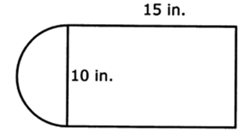

Task 2: Use a picture to justify your answer.
Joe is viewing several coins in his coin collection to determine which ones he needs to buy and how he will fit them into the coin book. He determines that the radius of a quarter is 1.6 cm. What is the circumference of the quarter Joe is viewing in his coin collection?

Task 3: Answer abstractly.
What is the area of this figure? Use 3.14 for π.
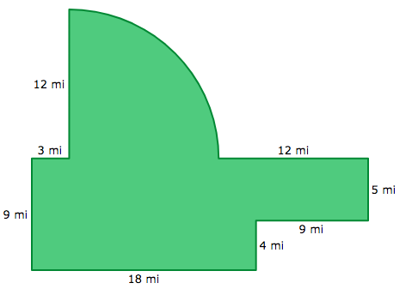
Grade 8

Task 1: Use concrete materials to show your answer.
Jessica makes clay bowls. The following equation relates the number of clay bowls, n, she makes and the total amount of money, d, in dollars, it costs her to make them.

d = 375 + 50n

Based on the equation, which of the following statements is true?
- Without making any clay bowls, Jessica’s total cost is $50.
- Without making any clay bowls, Jessica’s total cost is $375.
- Each clay bowl Jessica makes decreases her total cost by $50.
- Each clay bowl Jessica makes increases her total cost by $375.

Task 2: Use a picture to justify your answer.
Melissa saves money for six weeks to buy a sweater. She records her weekly savings. She saves $2.50 the first week. Each week she saves $1.25 more than she saved the previous week. How much will she save by week six?

Task 3: Answer abstractly.
What is the x-intercept and y-intercept of the graph?
