Date: |  |  | Duration of Lesson: 20-30 minutes
Title of Unit: Number and Operations |  |  | Title of Lesson: Absolute Value
Lesson Objectives:
- Students understand the absolute value of a number as its distance from zero on the number line.
- Students use absolute value to find the magnitude of a positive or negative quantity in a real-world situation.

Skills & Standards: CCLS - Math: 6.NS.7 Understand ordering and absolute value of rational numbers.
Progression of Learning & Teaching
Opener: | Eureka Math Grade 6 Module 3 Topic B Lesson 11 Opener  Students will be given a number line on display to analyze.  For this warm-up exercise, students work individually to record two different rational numbers that are the same distance from zero. Students find as many examples as possible and reach a conclusion about what must be true for every pair of numbers that lie that same distance from zero.  After two minutes:  - What are some examples you found (pairs of numbers that are the same distance from zero)? − 1 2 and 1 2 , 8.01 and −8.01,−7 and 7.  - What is the relationship between each pair of numbers? They are opposites.  - How does each pair of numbers relate to zero? Both numbers in each pair are the same distance from zero.  Discussion (3 minutes)  - We just saw that every number and its opposite are the same distance from zero on the number line. The absolute value of a number is the distance between the number and zero on a number line.  - In other words, a number and its opposite have the same absolute value.  - What is the absolute value of 5? Explain. The absolute value of 5 is 5 because it is 5 units from zero.  - What is the absolute value of −5? The absolute value of −5 is also 5 because it is also 5 units from zero.  - Both 5 and −5 are five units from zero, which makes 5 and −5 opposites.  - What is the absolute value of −1? 1  - What other number has an absolute value of 1? Explain. 1 also has an absolute value of 1 because 1 and −1 are opposites, so they have the same absolute value.  - What is the absolute value of 0? 0 |  |  | Points to Remember
Activities & Tasks: | Module 3 Topic B Lesson 11 Exercises 4-8  Guided Practice  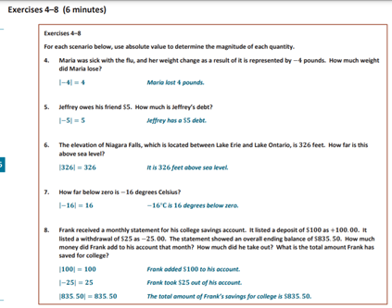  Module 3 Topic B Lesson 11 Exercises 9-19  Individual Practice  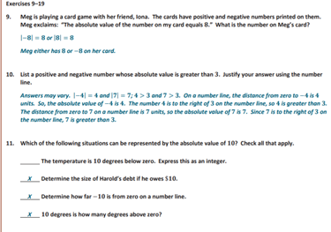  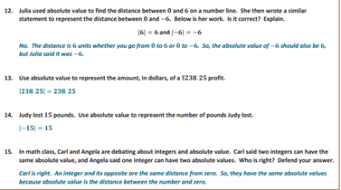  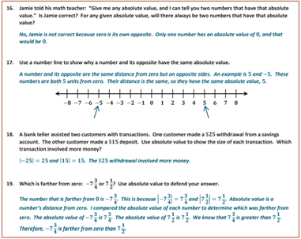  Closure Discussion  Exit Slip Assessment  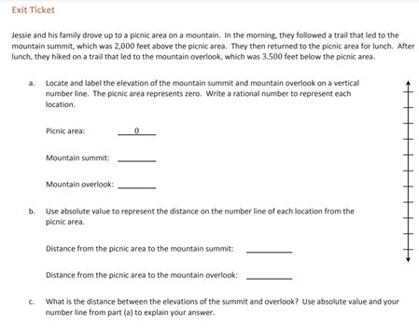 |  |  | Resources:  Examples from Videos:  Video #1: https://www.youtube.com/watch?v=LnfhdtjcpVY  Video #2: https://www.khanacademy.org/math/cc-sixth-grade-math/cc-6th-negative-number-topic/cc-6th-absolute-value/a/intro-to-absolute-value  Key Vocabulary:  - Absolute value- the magnitude of a real number without regard to its sign.  - Number line- a pictorial representation of numbers on a straight line. The numbers on a number line are placed sequentially at equal distances along its length. It can be extended infinitely in any direction and is usually represented horizontally. The numbers on a number line increase as one moves from left to right and decrease on moving from right to left.  - Rational numbers- a number that can be made by dividing two integers (an integer is a number with no fractional part).  - Magnitude- the size of something.  - Distance- length; a measurement of how far through space  Monitoring/Scaffolding:  Video #1: a= For auditory learners  Video #2 : with more words for visual learners  Timer for assignment  Teacher will walk around and monitor students who needs extra help.
Level of Cognitive Complexity: | ☐ Creating  ☒ Evaluating  ☒ Analyzing | ☒ Applying  ☒ Understanding  ☒ Remembering
Key questions: | - Can the absolute value of a number ever be a negative number? Why or why not?  - How can we use absolute value to determine magnitude?
Closure: | Closure Discussion  - I am thinking of two numbers. Both numbers have the same absolute value. What must be true about the two numbers?  - The numbers are opposites.  - Can the absolute value of a number ever be a negative number? Why or why not?  - No. Absolute value is the distance a number is from zero. If you count the number of units from zero to the number, the number of units is its absolute value. You could be on the right or left side of zero, but the number of units you count represents the distance or absolute value, and that will always be a positive number.  - How can we use absolute value to determine magnitude? For instance, how far below zero is −8 degrees?  - Absolute value represents magnitude. This means that −8 degrees is 8 units below zero.
Next Steps: | Analyze student results and prepare to re-teach/host intervention lessons or move on to lesson 12 dealing with the relationship between absolute value and order (ordering numbers). |  |  | Formative Assessment Criteria for Success:  Exit Ticket  Kahoot Activity (optional)

