Date: |  |  | Duration of Lesson: 30minutes
Title of Unit: Statistical Reasoning |  |  | Title of Lesson: Finding the Median
Lesson Objectives: How do I find the median of a set of numbers?
Groupings (e.g., whole class, small groups, co-teaching): whole class, and/or small group
Skills & Standards: 6.SP.B.5.c Giving quantitative measures of center (median and/or mean) and variability (interquartile range and/or mean absolute deviation), as well as describing any overall pattern and any striking deviations from the overall pattern with reference to the context in which the data were gathered.
Progression of Learning & Teaching
Opener: | Your teacher will give you an index card. Write your first and last names on the card. Then record the total number of letters in your name. After that, pause for additional instructions from your teacher. Display an example for all to see. |  |  | Points to Remember  Citations: Illustrative Math (2019)IM Math 6-8. Kendall Hunt Publishing Company. https://im.kendallhunt.com/MS/teachers/1/8/13/index.html CC By 4.0  Daniel Luevanos (2018). Median with Constraints. Open Middle, Accessed August 2022 https://www.openmiddle.com/median-with-constraints/ CC BY-NC-SA 4.0
Activities & Tasks: | - Find the Middle(adapted from IM 6-8 Open Up Resources): This activity introduces students to the term median. They learn that the median describes the middle value in an ordered list of data, and that it can capture what we consider typical for the data in some cases.  - Have students line up in order of the number of letters in their name. Then, those at both ends of the line count off and sit down simultaneously until one or two people in the middle remain standing. If one person remains standing, that person has the median number of letters. If two people remain standing, the median is the mean or the average of their two values.  - Explain to students that, instead of using the mean, sometimes we use the “middle” value in an ordered list of data set as a measure of center. We call this the median. Guide students through the activity:  - Ask students to stand up, holding their index cards in front of them, and arrange themselves in order based on the number of letters in their name. (Consider asking students to do so without speaking at all.) Look for the student whose name has the fewest letters and ask him or her to be the left end of the line. Ask the student with the longest full name to be the right end of the line. Students who have the same number of letters should stand side-by-side.  - Tell students that, to find the median or the middle number, we will count off from both ends at the same time. Ask the students at the two ends of the line say “1” at the same time and sit on the floor, and the students next to them to say “2” and then sit down, and so on. Have students count off in this fashion until only one or two students are standing.  - If the class has an odd number of students, one student will remain standing. Tell the class that this student’s number is the median. Give this student a sign that says “median” If the class has an even number of students, two students will remain standing. The median will be the mean or average of their numbers. Ask both students to hold the sign that says “median.” Explain that the median is also called the “50th percentile,” because half of the data values are the same size or less than it and fall to the left of it on the number line, and half are the same size or greater than it and fall to the right.  - Ask students to find the median a couple more times by changing the data set (e.g., asking a few students to leave the line or adding new people who are not members of the class with extremely long or short names). Make sure that students have a chance to work with both odd and even numbers of values.  - Practice with a partner:  Here is a data set from Ms. Gutierrez’s class on the numbers of siblings each student has.  (Feel free to change based on your class data).  1, 0, 2, 1, 7, 0, 2, 0, 1, 3  - Sort the data from least to greatest, and then find the median.  - In this situation, do you think the median is a good measure of a typical number of siblings for this group? Explain your reasoning.  - Here is the dot plot showing the travel time, in minutes, of Blake’s bus rides to school.  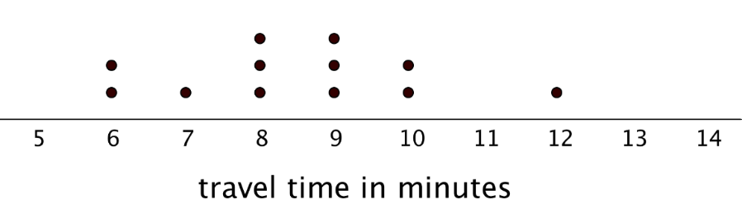  - Find the median travel time. Be prepared to explain your reasoning.  - What does the median tell us in this context?  - Open Middle Problem Median with Constraints from Open Middle Partnership by Daniel Luevanos: Create a statistical data set of at least 10 numbers such that (continue as next lesson opener as needed):  - All of the numbers in the data set are whole number.  - The median is not a whole number.  - The median is not part of the data set. |  |  | Resources: index cards and Student worksheets (see page 5-7)  Vocabulary: median is one way to measure the center of a data set. It is the middle value when the data set is listed in order.  Scaffolding/Differentiation:  Supports accessibility for: Memory; Language Representation: Develop Language and Symbols. Create a display of important terms and vocabulary. Include the following term and maintain the display for reference throughout the unit: median. Invite students to suggest language or diagrams to include on the display that will support their understanding of this term.
Level of Cognitive Complexity: | ☒Creating  ☐Evaluating  ☐Analyzing | ☐Applying  ☐Understanding  ☐Remembering
Key questions: | How do I put numbers in order from least to greatest? What would be the median of the set of data?
Closure: | Select a few students to share their responses to the questions about number of siblings, Blake's travel times, and Median with constraints. Focus the discussion on the median as another measure of the center of a data set and whether it captures what students would estimate to be a typical value for each data set.  Emphasize to students that the median is a value and not an individual. For example, if the last person standing in the class has 5 letters in their first name, the median is the number 5 and not the person standing. If there is another student who had 5 letters in their name, they might have switched places with the last person standing when lining up initially. Although the person standing changed, the median remains the same value of 5.  At this point, it is unnecessary to compare the mean and the median. Students will have many more opportunities to explore the median and think about how it differs from the mean in the upcoming activities.
Next Steps: | The next few days will be a combination of mean, median, mode and range. With this group of students, we have to go one step at a time and then combine them together. |  |  | Formative Assessment Criteria for Success:  The evidence of mastery today would be their classwork assignment working independently.

Name:_______________________________________________ Student Worksheet
Find the Middle
Number of letters in their name. Record data set from students in the class.
___, ___, ___, ___, ___, ___, ___, ___, ___, ___, ___, ___, ___, ___, ___, ___, ___, ___, ___, ___, ___, ___, ___, ___, ___

Re-arrange based on the number of letters in the name. (fewest on the left, longest on the right)
___, ___, ___, ___, ___, ___, ___, ___, ___, ___, ___, ___, ___, ___, ___, ___, ___, ___, ___, ___, ___, ___, ___, ___, ___

Cross out as students sit down.

Median = ____

Number of letters in their name. Record data set from students in the class.
___, ___, ___, ___, ___, ___, ___, ___, ___, ___, ___, ___, ___, ___, ___, ___, ___, ___, ___, ___, ___, ___, ___, ___, ___

Re-arrange based on the number of letters in the name. (fewest on the left, longest on the right)
___, ___, ___, ___, ___, ___, ___, ___, ___, ___, ___, ___, ___, ___, ___, ___, ___, ___, ___, ___, ___, ___, ___, ___, ___

Cross out as students sit down.

Median = ____

Partner Practice:
Data set that represents the number of siblings students in Ms. Guiteraz’s class has:
1, 0, 2, 1, 7, 0, 2, 0, 1, 3
Sort the data from least to greatest, and then find the median.
___, ___, ___, ___, ___, ___, ___, ___, ___, ___,
Median =____
In this situation, do you think the median is a good measure of a typical number of siblings for this group? Explain your reasoning

The dot plot showing the travel time, in minutes, of Blake’s bus rides to school.
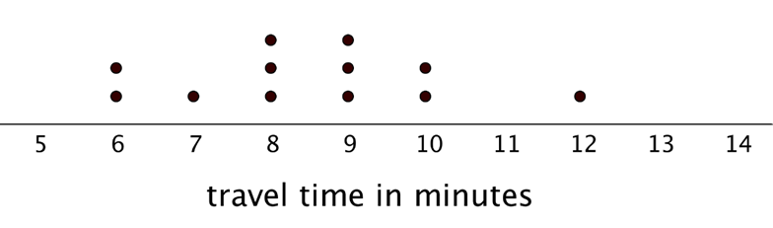
Find the media travel time. Be prepared to explain your reasoning to the class.
Median=_____

What does the median tell us in this context?

Open Middle Problem:
Create a statistical data set of at least 10 numbers such that(continue as next lesson opener as needed):
- All of the numbers in the data set are whole number.
- The median is not a whole number.
- The median is not part of the data set.

