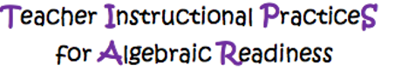

Grade Level: 6
CCSS: CCSS.MATH.CONTENT.7.G.A.1
CCSS.Math.Content.4.G.A.1

Date: |  |  | Duration of Lesson: 3 days
Title of Unit Angle Measurement |  |  | Title of Lesson: Intro to using a protractor to measure angles
Lesson Objectives: I can draw and measure angles that will be needed to make a sled kite pattern and enlarge the pattern 3 or 4 times the size.
Groupings : Whole class, Individual help
Skills & Standards:
CCSS.MATH.CONTENT.7.G.A.1
Solve problems involving scale drawings of geometric figures, including computing actual lengths and areas from a scale drawing and reproducing a scale drawing at a different scale
CCSS.Math.Content.4.G.A.1
Draw points, lines, line segments, rays, angles (right, acute, obtuse), and perpendicular and parallel lines. Identify these in two-dimensional figures.

Progression of Learning & Teaching
Opener: | Review task cards to identify angles, line, points, ray. Tell students  that are going to explore using a protractor and explain how they can use it to measure angles. Define the vocabulary: |  |  | Points to Remember  - How to write an angle measurement  - Degree notation 90°  - Compare values of angles measured to Acute, Obtuse, Right angles for reasonability
Activities & Tasks: | - Students explore the protractors for 5 minutes. Show the image of the protractor to students with the references to Inner Scale, Outer Scale, Center, and Base Line.  - Next, have students walk around the room and explore real-world angels within the classroom. I.e., Use classroom doors to have students see and discover different angles based on how much the door is open or closed.  - Model using a protractor  - Draw an angle for class (smart board, or other projector)  - Interactive protractor for demo https://teachablemath.com/apps/protractor-practice-app/  - Each group will draw angles on paper and use a protractor to measure and determine the measure of the angle they drew. Identify the angle drawn and use correct scale to choose the correct angle measurement.  - As students measure their angles ask them to compare the degrees they determined for their angle and how it compares to an acute angle, obtuse angle or right angle. Does their measurement make sense in that comparison  - Whole group share out: Do any of the groups have the same angle. Group students with three or four students in each group. Then have the students work in the angle packet to draw. Discuss the first and second scale. Identify the angle drawn and use to correct scale to choose the correct angle measurement. The teacher will check in with each group to check for understanding and help correct any errors.  - Create anchor chart for classroom with the following:  - Acute angle, picture and definition  - Obtuse angle, picture and definition  - Right angle, picture and definition  - Enlarged image of protractor with labels |  |  | Resources:  - Angle packet https://cdn.kutasoftware.com/Worksheets/Geo/2-Angles%20and%20Their%20Measures.pdf, protractors, rulers, kite pattern, Desmos link https://teacher.desmos.com/activitybuilder/custom/60269d795bbcf00bbf60d1c5  Key Vocabulary:  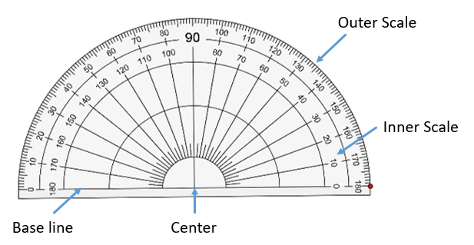  - Angle: Two rays sharing the same endpoint (called the angle vertex).  - Angle Measurement Symbol  - Acute Angle: An angle whose measure is between 0° and 90° or with less than 90°  - Obtuse Angle: An angle measuring between 90° and 180°.  - Right Angle: An angle equal to 90°.  - Straight Angle- an angle of 180°  - Protractor: A semi-circle device used for measuring angles. The edge of a protractor is subdivided into degrees.  - Degrees: the unit of measure used for angles  - Vertex of Angle: The point of intersection between two rays, often called a corner. A vertex is where two-dimensional sides or three-dimensional edges meet.  - Center: (hole) of the protractor  - Outer Scale: Shows degrees marked clockwise from 0° to 180°  - Inner Scale: Shows anti-clockwise from 0° to 180°  Monitoring/Scaffolding: Today is an introduction. As the lessons progress, I will give students more control of the of scaling their kite pattern.  By grouping students together, this will help the students who are struggling to ask their peers for help.
Level of Cognitive Complexity | - Creating  ☒ Evaluating  - Analyzing | Applying  ☒ Understanding  - Remembering
Key questions: | Why is measuring angles accurately something we need to do in the real-world?
Closure: | During the last 5 minutes bring the class back to the whole group and discuss what they learned and review vocabulary using desmos. The teacher will call on each group to discuss one angle they completed and what they learned.  As students work in the angle packet on day 2, check work as students go to determine their accuracy and the necessity to do a third day.  After students have completed the Angle packet, check each student's work. The packet will not be completed during the first class period, it should take students at least two class periods possibility three class periods.
Next Steps: | More practice involving angle measurement and drawing.  Make a sled kite pattern (possible lesson to embed https://cdn.kutasoftware.com/Worksheets/Geo/2-Angles%20and%20Their%20Measures.pdf), enlarge it 3 or 4 times as big, construct the kite and fly. |  |  | Formative Assessment/Criteria for Success  - Since this is an introduction to drawing and  measuring angles, I will be monitoring the students and watching for common mistakes.

