Date: |  |  | Duration of Lesson: 3 days
Title of Unit: Statistical Reasoning |  |  | Title of Lesson: Mean, median, mode with box whisker plot
Lesson Objectives:
1. Define mean, median and mode to identify data in graphs.
2. Understand mean in order to maintain an average of 80 % or more, 70 % or more.
Groupings (e.g., whole class, small groups, co-teaching): whole class
Skills & Standards:
CCSS.MATH.CONTENT.6.SPA.1 Recognize a statistical question as one that anticipates variability in the data related to the question and accounts for it in the answers.
CCSS.MATH.CONTENT.6.SPA.2 Understand that a set of data collected to answer a statistical question has a distribution which can be described by its center, spread, and overall shape.
CCSS.MATH.CONTENT.6.SPA.3 Understand that both a measure of center and a description of variability should be considered when describing a numerical data set.
a. Determine the measure of center of a data set and understand that it is a single number that summarizes all the values of that data set.
CCSS.MATH.CONTENT.6.SPA.4 Display numerical data in plots on a number line.
• Use dot plots, histograms, and box plots to represent data.
• Compare the attributes of different representations of the same data
CCSS.MATH.CONTENT.6.SPA.5 Summarize numerical data sets in relation to their context.
Progression of Learning & Teaching
Opener: | - Review mean, median and mode using assessment data and how teachers complete reports at the end of the quarter.  - Ed Puzzle (modified) box and whisker Ed Puzzle https://edpuzzle.com/discover |  |  | Points to Remember
Activities & Tasks: | - Create index cards with mean, median, mode with definitions and examples revisiting each vocabulary word on separate days  - Teacher created anchor chart with number lines, different graphs and box whisker plots.  - Take 5 Ed Puzzle grades, or other assessment source, to calculate mean, median and mode.  - Create an anchor chart as a class. Students will use the anchor chart to make their own one pager in their notebooks using the mean, mean mode, range, outlier, and box whisker plot.  - Students take 10 data points from their grades from recent assessments in class to calculate the mean, median, mode and draw a box whisker plot. Students should compare and contrast their measures of center for their grade. Mean is the grade reflected in the grade book. Have students determine what scores on future assignments they would need to have a higher mean for the class. |  |  | Resources/ Materials:  Anywhere math video  Covid Data  Index cards  Easel paper for Anchor Charts to remain in room  Vocabulary:  Box & whisker plot 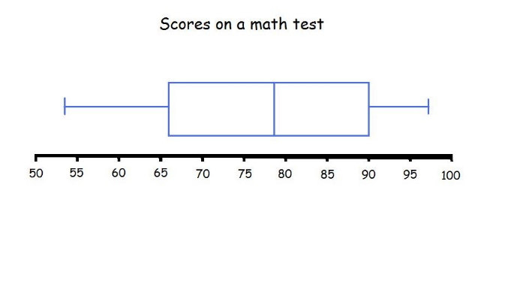  - Statistics: the collection, organization, analysis, interpretation, and presentation of data  - Data: facts and statistics collected together for reference or analysis  - Numerical data: is information in number form  - Number line: the horizontal straight lines in which the integers are placed in equal intervals  - Histogram: A graph that uses bars that equal ranges of values  - Observational data: a systematic way to collect data by observing people in natural situations or settings  - Measurement: a process of determining how large or small a physical quantity is  - Mean: The mean is the same as the average. Add up a series of numbers and divide the sum by the total number of values to find the mean.  - Median: the "middle value" in a series of numbers ordered from least to greatest. When the total number of values in a list is odd, the median is the middle entry. When the total number of values in a list is even, the median is equal to the sum of the two middle numbers divided by two.  - Mode: The mode in a list of numbers are the values that occur most frequently  - Range: the difference between the highest values and lowest values in a given set of numbers  - Interquartile range the range of values that resides in the middle of the scores  - Outlier: an outlier is a data point that differs significantly from other observations  - Dot plot: data points plotted as dots on a graph with an x- and y-axis  Monitoring/Scaffolding:  - During the first activity of calculating measures of central tendency for five assessments, check for student accuracy:  - Check in with whole class after each calculation to see how they are doing before moving onto the next one.  - For those students who have accurate calculations, consider pairing them with a student who is struggling to ‘teach’ their peer the process  - For struggling students consider providing a graphic organizer for example:  - 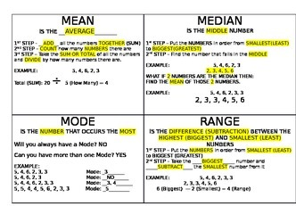
Level of Cognitive Complexity: | ☐ Creating  ☐ Evaluating  ☐ Analyzing | X☐ Applying  ☐ Understanding  ☐ Remembering
Key questions: | - Where is statistical data such as mean, median, mode used in real life situations?  - Why is using statistical data important to:  - teachers  - sports  - Other real world situations  - Why is it better to use different graphs and diagrams to understand data?
Closure: | Discuss data from 3 states on people who are receiving Covid vaccination shots and create a poster.
Next Steps: | Apply mean, median, and mode to other real-life situations. Gather data from school, student experiences. |  |  | Formative Assessment Criteria for Success:  - Exit ticket choose one of the following problems:  - A student took 5 quizzes and had a mean score of 72. If four of the quizzes were 75,82,63 and 74 what was the fifth quiz score (66)  - Create a list of four quiz scores with an average of approximately 74, with no score lower than a 60

