Date: |  |  | Duration of Lesson: 20-30 minutes
Title of Unit: Angles |  |  | Title of Lesson: Angle Vocabulary
Lesson Objectives: Students will be able to identify and draw angles based on a companion angle.
Use facts about supplementary, complementary, vertical, and adjacent angles in a multi-step problem to write and solve simple equations for an unknown angle in a figure.
Groupings (e.g., whole class, small groups, co-teaching): whole group
Skills & Standards:
CCSS.MATH.CONTENT.7.G.B.5
Use facts about supplementary, complementary, vertical, and adjacent angles in a multi-step problem to write and solve simple equations for an unknown angle in a figure.
Progression of Learning & Teaching
Opener: | - Students will begin the lesson by using a ruler, protractor, pencil and paper to draw straight, right, acute, and obtuse angles or students may choose to draw an angle that is NOT representative of these angles  - Students will explain why their angles either fit or DO NOT fit the description.  - Go over the objectives of the lesson so students know what they are expected to learn  - Discuss with students that there are angle relationships in addition to types of angles and that is today’s lesson, how angle relationships help us solve problems |  |  | Points to Remember  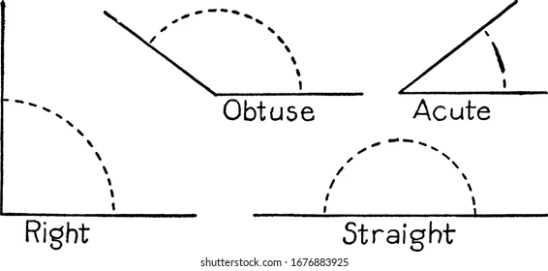  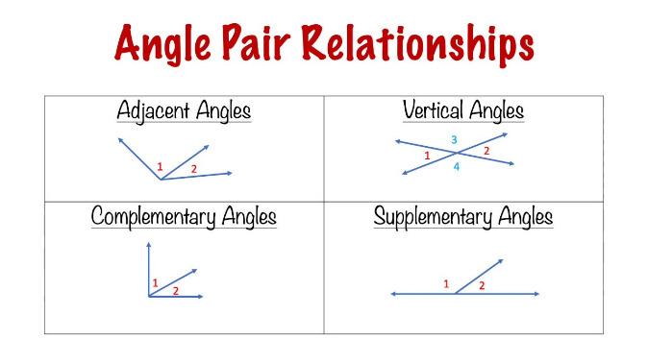
Activities & Tasks: | Instructional Lesson: (include as much detail as needed for others to understand the lesson)  Provide students with an alternative to using the white boards by providing students with pipe cleaners to have them make the angles with the concrete object  - We Do: Facilitate a class discussion  - Write the word adjacent on the board–have students share what the word means to them. Explain that in mathematics it has a similar meaning when naming/drawing angles (the angles share a side).  - Student:  - Students are to draw adjacent angles on their white board to show understanding.  - We Do:  - Instructor writes the words complementary angles degrees written in on the board and, without saying anything, draws three examples of complementary angles.  - Start discussion to have students determine what complementary angles are.  - Y’all Do:  - Students draw examples of complementary angles and share what they have done, explaining why the angles are complementary to a partner.  - We Do;  - Instructor writes the words supplementary angles degrees written in on the board and without saying anything draws three examples of supplementary angles.  - Start discussion to have students determine what supplementary angles are.  - Y’all Do:  - Students draw examples of supplementary angles and share what they have done, explaining why the angles are supplementary to a partner.  - We Do:  - Instructor writes the words vertical angles on the board and draws an example of vertical angles with degrees written in. Angles need to be labeled to help with identification and degrees need to be included.  - Students share their understanding of what makes a pair of vertical angles and what must be true about their degrees  - Y’all Do:  - Students will work in pairs or small groups and test each other on their understanding of the lesson by asking other(s) to draw and justify their drawings of the different types of angles of the day’s lesson.  - After group work, put easel paper on walls, provide students with sticky notes, have them do a gallery walk and identify what the angles represent on the images provided on the easel paper, in each case students must identify the angle or angle relationship and answer ‘how do you know?’ |  |  | Resources:  Vocabulary:  - List vocabulary in lesson  - adjacent angles (share a side)  - complementary angles (90-degrees)  - supplementary angles (180-degrees)  - vertical angles (pair of opposite angles formed by intersecting lines)  - The purpose of the lesson is to teach the vocabulary  - Students have a knowledge of what angles are and are able to use a protractor to both find the measure of and create an angle with a predetermined amount of degree  - Monitoring/Scaffolding:  - Students will be showing their understanding of the concept throughout the lesson  - Individual attention can be given to those who may not totally grasp the concept
Level of Cognitive Complexity: | ☐ Creating  ☐ Evaluating  ☐ Analyzing | ☐ Applying  ☐ Understanding  ☐ Remembering
Key questions: | - How can knowing the different types of angles and how they relate to one another help in determining the number of degrees in the angles?
Closure: | - Students will share out what they have learned during the lesson.  - Exit ticket give students one angle on a piece of paper and ask them to either make a vertical, adjacent, complementary, or supplementary angle and explain why their drawing meets the relationship criteria
Next Steps: | Continue with lessons from the text. |  |  | Formative Assessment/Criteria for Success:  - Checks will be done on student work throughout the lesson. Understanding of the concept will show in later work.  Exit ticket

