Date: |  |  | Duration of Lesson: 25 Minutes
Title of Unit: Math Talks |  |  | Title of Lesson:
Lesson Objectives: Students will be able to connect the use of algebra tiles to understanding algebraic expressions
Groupings (e.g., whole class, small groups, co-teaching): Whole Class
Skills & Standards: CCSS.MATH.CONTENT.7.EE.A.1: Use properties of operations to generate equivalent expressions.
Apply properties of operations as strategies to add, subtract, factor, and expand linear expressions with rational coefficients.
Progression of Learning & Teaching
Opener: | - On each desk, there will be a set of algebra tiles for when the students enter the room.  - Because this is a discovery lesson, the goals will not be presented at the beginning.  - Students will begin by making observations about their tiles |  |  | Points to Remember  Picture from EMBIBE  Notation:  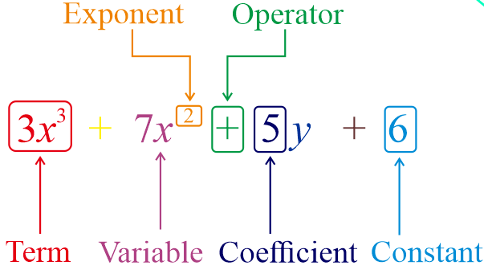
Activities & Tasks: | Instructional Lesson: (include as much detail as needed for others to understand the lesson)  - Give students time to work with the tiles.  - Ask: “What did you notice? What do you wonder about?”  - Student: students will find ways to group their tiles in a way that makes sense to them and that they can explain to others.  - We Do: Facilitate a class discussion  - What do you notice?  - How can the tiles be grouped?  - List ideas on the board  - “Can you come up with a different way to organize the tiles?”  - Decide as a class (with guidance) what the tiles actually stand and can be used for. Be sure to correct any misconceptions that may arise.  Activities/Tasks:  - Sorting of tiles  - Discussing |  |  | Resources:  - Set of algebraic tiles for each student  - Individual whiteboard, marker, and eraser for students  - Large whiteboard and markers to record student observations  - A Beginner's Guide to Teaching with Algebra Tiles video  - Desmos Algebra Tiles activity builder  - Desmos Algebra Tiles: Equations and Expressions  - Desmos Algebra tiles for combining like terms  - Desmos Algebra Tile Challenges  Vocabulary:  - Algebra tiles - Algebra tiles are square and rectangle-shaped tiles that represent numbers and variables  - Algebraic Expression – a symbol or a combination of symbols used in algebra, containing one or more numbers, variables, and arithmetic operations  - Term – a single mathematical expression  - Coefficient – a numerical or constant quantity placed before and multiplying the variable in an algebraic expression  - Variable – a symbol (usually a letter) standing in for an unknown numerical value in an expression and equation  - Exponent – a symbol written above and to the right of a mathematical expression to indicate the operation of raising to a power  - Like terms – Terms whose variables (such as x or y) with any exponents (such as the 2 in $x^{2}$) are the same  - Unlike terms - Algebraic terms, which does not have the same literal coefficients, and cannot be raised to the same power  - Constant- a value or number that never changes in expression  Scaffolding/Differentiation:  - Be sure to check on each student for understanding
Level of Cognitive Complexity: | ☐ Creating  ☐ Evaluating  ☐ Analyzing | ☐ Applying  ☐ Understanding  ☐ Remembering
Key questions: | - What mathematical concept(s) could the tiles be used to help with understanding?
Closure: | - Exit ticket: Using the algebra tiles, create one expression that contains four terms, two variables and at least one coefficient.
Next Steps: | - Use the tiles to help when teaching about Algebraic Expressions |  |  | Formative Assessment Criteria for Success:  - After further instruction, student will be able to solve homework assignments by combining like terms in Algebraic Expressions.

