Date: |  |  | Duration of Lesson: 35 minutes
Title of Unit: Explore and Explain the Properties of Transformations |  |  | Title of Lesson: Reflections on the Coordinate Plan
Lesson Objectives: Students will be able to create the reflected image and identify the algebraic rule used to reflect the image
Groupings (e.g., whole class, small groups, co-teaching): Whole Class and partner during work time.
Skills & Standards: 8.G.A.1, 8.G.A.2, 8.G.A.3, 8.G.A.4
Progression of Learning & Teaching
Opener: | - The lesson will start with a translations warm up. Students will complete the warmup and will be given time to collaborate with their classmates as they explain why they chose the answer that they chose.  - Watch the PBS translation video  - Complete the warm-up problem (see student worksheet below: problems adapted from IM 6-8 Math by illustrative Math) OR the GeoGebra Interactive Translations Activity: https://www.geogebra.org/m/zxEdEvzM |  |  | Points to Remember  - Learning Targets are posted as usual and will be presented in the lesson.  - Students should be able to determine if a given transformation preserves congruency and orientation.
Activities & Tasks: | - Review the previously taught transformations and their connection to the transformation formulas based on the coordinate pair  - $P(x,y)$à$P'\left(x±h, y±h\right)$  - Model how to solve reflection of points and polygons about the x-axis and y-axis (I do). Let them practice with me and/or with a partner (We do), then let them work independently or with a partner on the assignment (You do).  I Do:  Five points are plotted on the coordinate plane  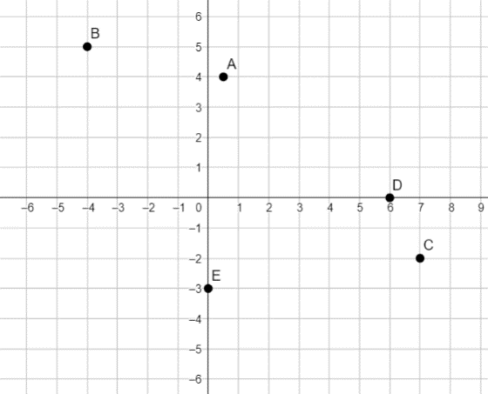  - Label each with its coordinates.  - Using the x-axis as the line of reflection, plot the image of each point and label the coordinates  - Remind students of the label notation A’, B’, C’, etc.  - If the point $\left(13, 10\right)$ were reflected using the x-axis as the line of reflection, what would be coordinates of the image? What about $\left(13, 20\right)$ ? $\left(13, 570\right)$? Explain how you know.  We Do:  The point R has coordinates $\left(3, 2\right)$  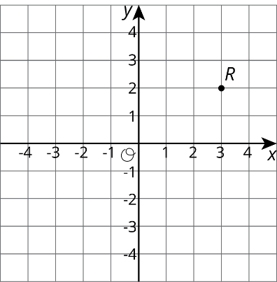  Without graphing, predict the coordinates of the image of point R if point R were reflected using the y-axis as the line of reflection.  - Check your answer by finding the image of R on the graph.  - Label the reflection of point R as R’.  - What are the coordinates of R’?  - Suppose you reflect a point using the y-axis as line of reflection. How would you describe its image?  Let’s Reflect Polygon P over the Y-axis. What are the coordinate points of polygon P?  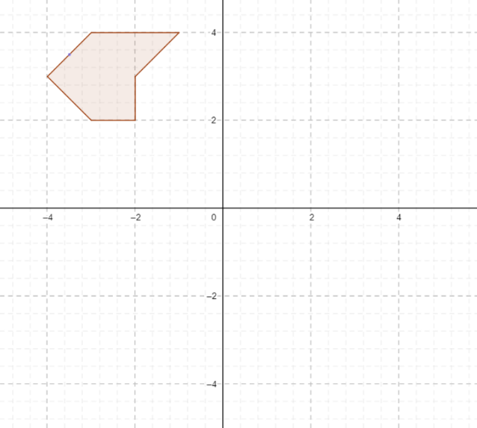  Label the Reflected polygon P’ and label the coordinates.  You Do:  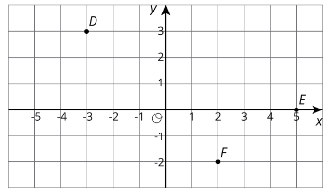  - Here are some points. What are the coordinates of D, E, and F after a reflection over the y-axis? Plot these points on the grid, and label them D’, E’, and F’.  - Here is a Trapezoid A in the coordinate plane.  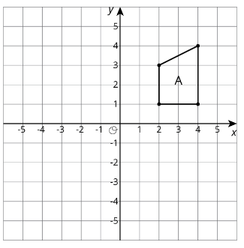  - Draw Polygon B, the reflection of A, using the y-axis as the line of reflection.  - Draw Polygon C, the reflection of B, using the x-axis as the line of reflection.  - Draw Polygon D, the image of C using the x-axis as the line of reflection.  Push/Extension:  Create Polygon A’B’C’D’ which is the image of ABCD after some transformations. Document the transformations and plot the new locations on the coordinate grid. Share with a partner to test your transformations. adjust as needed.  Check for Understanding:  The check for understanding will be an assignment that is to be completed in class and turned in before they leave.  Check for Understanding Prompt: Describe a sequence of transformations for which Triangle B is the image of Triangle A |  |  | Resources:  - Google Slide will be used to display images and to go over examples.  - Students will have a copy of the notes that I am going over, but need to write down what I write down so they have a support to reference during independent work time.  - Students should use the demos calculator  - PBS video about translations with notation  Vocabulary:  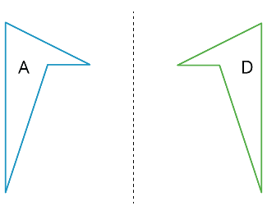  - A reflection places points on the opposite side of a reflection line. The mirror image is a backwards copy of the original figure. The reflection line shows where the mirror should stand. For example, Figure A was reflected across the dotted line. Figure D is a reflection of Figure A.  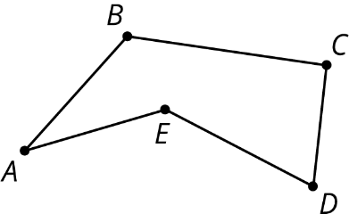  A vertex is a point where two or more edges meet. When we have more than one vertex, we call them vertices. The vertices in this polygon are labeled A, B, C, D, and E.  Scaffolding/Differentiation:  Chunk this task into more manageable parts to differentiate the degree of difficulty or complexity. For example, to get students started, provide a smaller bank of points and only the first two instructions. Once students have successfully completed the four steps for each, present the remaining questions, one at a time.  Compare and Connect when students present their strategies for reflecting points using the x-axis as the line of reflection before continuing on. Ask students to consider what is the same and what is different about the strategies. Draw students’ attention to the different ways students reasoned to find the reflected coordinates. These exchanges strengthen students’ mathematical language use and reasoning of reflections along the x-axis and y-axis.  Providing the option for the Extension Push Problem to create a polygon from a series of transformations.
Level of Cognitive Complexity: | ☐Creating  ☒Evaluating  ☒Analyzing | ☐Applying  ☐Understanding  ☒Remembering
Key questions: | - Will congruency be preserved? Why or why not?  - Will orientation be preserved? Why or why not?  Is this reflection over the x or the y axis and how can you tell?
Closure: | The lesson will close with a review of solving problems involving reflections over the x and y axis on the coordinate plane. Then students will work on the assignment.  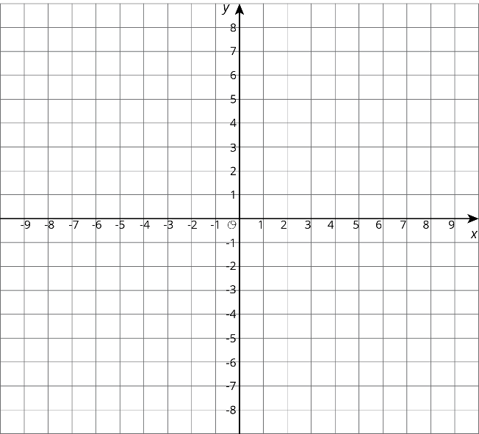  To facilitate discussion, display a blank coordinate grid. Questions for discussion:  - "When you have a point and an axis of reflection, how do you find the reflection of the point?"  - "How can you use the coordinates of a point to help find the reflection?"  - "Are some points easier to reflect than others? Why?"  - "What patterns have you seen in these reflections of points on the coordinate grid?"  The goal of the activity is not to create a rule that students memorize. The goal is for students to notice the pattern of reflecting over an axis changing the sign of the coordinate (without having to graph). The coordinate grid can sometimes be a powerful tool for understanding and expressing structure and this is true for reflections over both the x-axis and y-axis.  Highlight working on the coordinate plane when doing transformations, ask:  •"What are some advantages to knowing the coordinates of points when you are doing transformations?"  •"What changes did we see when reflecting points over the x-axis? y-axis?"  Time permitting, ask students to apply a few transformations to a point. For example, where does(1,2) go when  •reflected over the x-axis? (1, -2)  •reflected over the y-axis ? (-1, 2)
Next Steps: | Review the formative assessment of translations and reflections to ensure students understand them conceptually and how that relates to the procedure that can be used on coordinate points when doing transformations. |  |  | Formative Assessment Criteria for Success:  The formative assessment includes translation questions for the warm-up and reflection question for the check for understanding. Student responses are collected for immediate feedback on how well they understood the content.

Name:_______________________________________ Student Worksheet
Reflections on the Coordinate Plane
Warm-up
- Describe the transformation depicted below from $∆ABC-→ ∆A'B'C'$
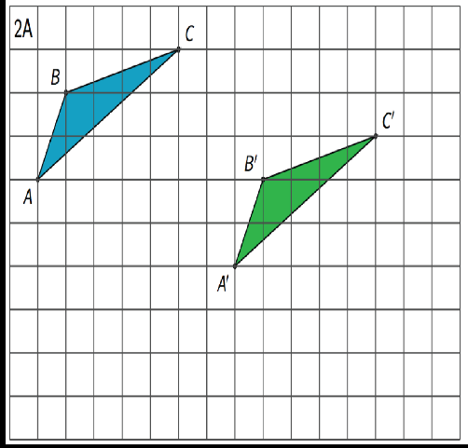

- Select all the translations that take Triangle T to Triangle U. There may be more than one correct answer.
A. $Translate \left(-3, 0\right) to \left(1, 2\right)$
B. $Translate \left(2, 1\right) to \left(-2, -1\right)$
C. $Translate \left(-4,-3\right) to \left(0,-1\right)$
D. $Translate \left(1, 2\right) to \left(2, 1 \right)$

Warm-up Problems Adapted from IM 6-8 Math 2019 by Illustrative Mathematics

I Do:
Five points are plotted on the coordinate plane
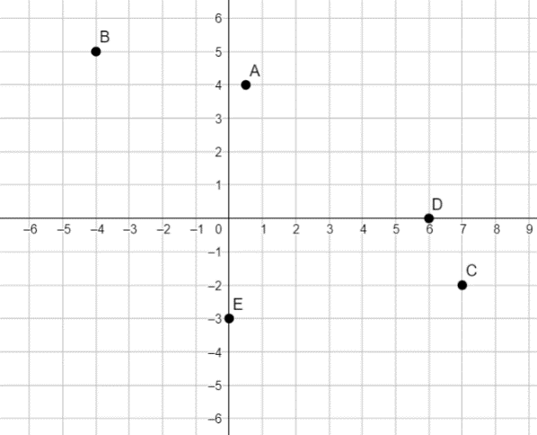
Label each with its coordinates.
Using the x-axis as the line of reflection, plot the image of each point and label the coordinates

- If the point $\left(13, 10\right)$ were reflected using the x-axis as the line of reflection, what would be coordinates of the image?

- What about $\left(13, 20\right)$ ?

- $\left(13, 570\right)$ ?

- Explain how you know.

We Do:
The point R has coordinates $\left(3, 2\right)$
Without graphing, predict the coordinates of the image of point R if point R were reflected using the y-axis as the line of reflection.
- Check your answer by finding the image of R on the graph.
- Label the reflection of point R as R’ .
- What are the coordinates of R’ ?
- Suppose you reflect a point using the y-axis as line of reflection. How would you describe its image?

Let’s Reflect Polygon P over the Y-axis. What are the coordinate points of polygon P?
Label the Reflected polygon P’ and label the coordinates.

You Do
- Below are some points on the coordinate plane. What are the coordinates of D, E, and F after a reflection over the y-axis? Plot these points on the coordinate plane and label them D’, E’, and F’. 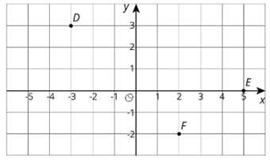

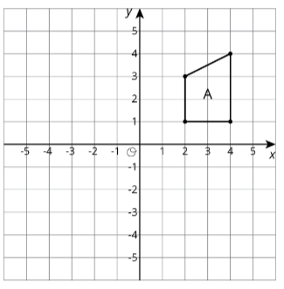
- Here is a Trapezoid A in the coordinate plan.
Draw Polygon B, the reflection of A, using the y-axis as the line of reflection.

Draw Polygon C, the reflection of B, using the x-axis as the line of reflection.

Draw Polygon D, the image of C using the x-axis as the line of reflection.

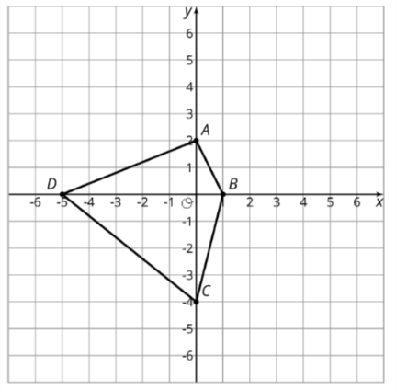
Extension/Push:
Create Polygon A’B’C’D’ which is the image of ABCD after some transformations. Document the transformations and plot the new locations on the coordinate grid. Share with a partner to test your transformations. adjust as needed.

Check for Understanding:
Describe a sequence of transformations for which Triangle B is the image of Triangle A

