Date: |  |  | Duration of Lesson: 50 minutes
Title of Unit: Linear Equations: Slope and Equations of Lines |  |  | Title of Lesson: Let’s Ski: Slope in Action
Lesson Objectives: Students will identify positive, negative, and no slope lines. Students will determine slope of each line.
Groupings (e.g., whole class, small groups, co-teaching): Whole Class Mini Lesson, Small Group Activity
Skills & Standards:
CCSS.MATH.CONTENT.8.EE.B.5
Graph proportional relationships, interpreting the unit rate as the slope of the graph. Compare two different proportional relationships represented in different ways. For example, compare a distance-time graph to a distance-time equation to determine which of two moving objects has greater speed.

CCSS.MATH.CONTENT.8.EE.B.6
Use similar triangles to explain why the slope m is the same between any two distinct points on a non-vertical line in the coordinate plane; derive the equation y = mx for a line through the origin and the equation y = mx + b for a line intercepting the vertical axis at b.

Progression of Learning & Teaching
Opener: | 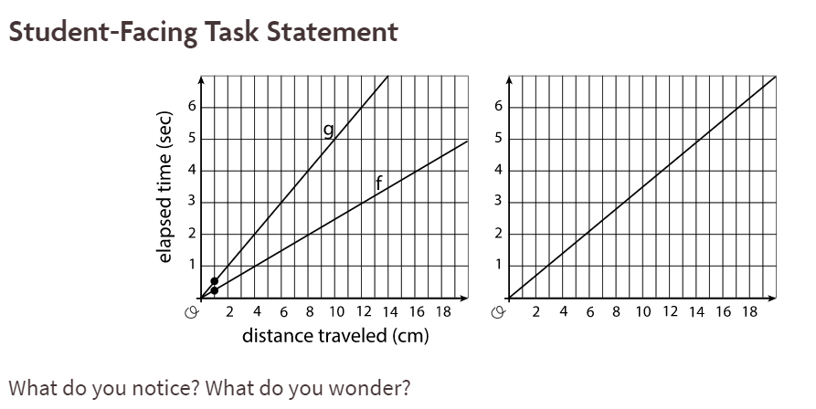  (From Open Up, Grade 8 Unit 3.1) |  |  | Points to Remember  Possible Responses  Things students may notice:  - The second set of axes are not labeled.  - If the first graph is about speed, then is twice as fast as.  - Graph is something going a speed of 2 centimeters every second.  - Graph is something going a pace of about 0.25 seconds per 1 centimeter.  Things students may wonder:  - What do the two points mean?  - Why does one graph show two lines while the other only has one?  - What does the second graph represent?
Activities & Tasks: | Instructional Lesson:  Activities/Tasks:  Students will be asked where slope can be seen in life. If needed, to help students know what slope means, ask them about ski slopes and what those are? Write the list on the board or easel paper for whole group discussion  Next show students a video (https://youtu.be/avS6C6_kvXM can be others like this). Watch a couple of minutes, and ask the students where was the slope seen? Discuss (freeze frames) going downhill (negative slope), going uphill (positive slope), skiing in a straight line (no slope). This allows students to visually see slopes in action.  Part 1:  Next, each student will be creating a ski course on graph paper in small groups. Students should be encouraged to use rulers to have straight lines drawn which will help them later on. They do not need to determine the slope at this point, but be able to share positive lines, negative lines, and no slope lines on their paper. Students must have five different points on their paper with some feature at each point in which the slope is changing (rock, tree, flag, etc). Have students share their papers within their small groups discussing which lines appear to be positive, negative, or no slope. Allow natural discussion to occur. Then bring the class back to discuss whole class. Another option is to allow students to use thin spaghetti to show their lines on the graph paper. If available geoboards provide a hands on way to create ski slopes with rubber bands and calculate slope, rubber bands can be used to create the triangle after the ski slope is completed.  Part 2:  Next have students fold their paper into four quadrants (by folding the paper evenly down the middles of the paper). Students may wish to darken in these lines. Have students then determine the slope of a line by using the triangle method (share image with students to remind them about the triangle method) to find the slope. Have students record each slope on their paper. |  |  | Resources: Graph paper, colored pencils, ruler, video of slope; thin spaghetti for lines on graph paper; geoboards & rubber bands  Vocabulary:  Slope: shows the steepness or incline of a line and is determined by comparing the positions of two points on the line (usually on a graph)  Ratio: The relationship between two quantities.  Positive slope : the line goes up from left to right and the slope value is greater than zero  Negative slope: the line goes down from left to right and the slope value is less than zero  Zero slope: when there is no change in the Y values of the ordered pairs; creates a horizontal line  Undefined slope: When there is no change in the X values of the ordered pairs; creates a vertical line  Rise: the change in the values of the Y coordinate  Run: the change in the values of the X coordinate  Slope triangle image  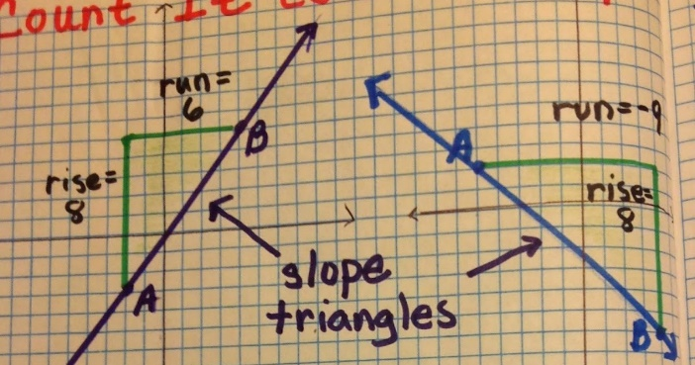  Monitoring/Scaffolding:  Monitoring/Scaffolding:  Extend by having students determine the y-intercept of the lines they have drawn. You can also discuss undefined slope.  Watch for students forgetting negative signs.  Watch for students not understanding using points on the graph to determine slope.  Sample picture:  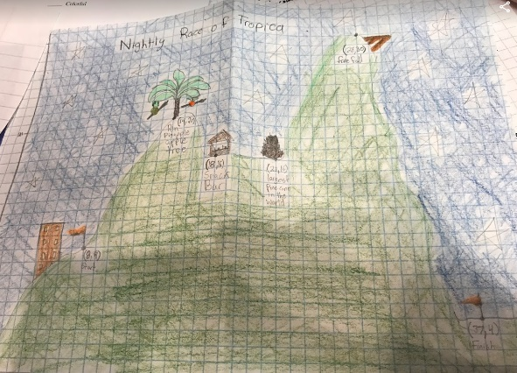
Level of Cognitive Complexity: | ☐ Creating  ☐ Evaluating  ☐ Analyzing | ☐ Applying  ☐ Understanding  ☐ Remembering
Key questions: | How can you tell if a slope is positive, negative, or no slope?  What happens if a slope is none of those?  How do we record slope? What do the parts of the fraction mean?
Closure: | Have students share their pictures talking about their slopes. Ask students to share their slopes. Then ask if they can share either a slope that is steeper (or not steeper) then one on another student’s graph. How can you tell?
Next Steps: | Move this activity into finding y-intercepts to write an equation of line.  Then given that information, have other students recreate someone else’s ski slopes with that given information. |  |  | Formative Assessment Criteria for Success:  - Teacher check in, ski slope paper and form, discussions (all informal)  - Students accurately determined slopes of different lines as well as determined if it is positive, negative, or no slope.

Student Worksheet:

Name: _____________________________________________________

Object placement (list item: tree, pole, rock, etc) _______________________ Slope: _____________________
Explain how you calculated the slope (show your work or explain what you did)

Is your slope positive, negative, zero, or undefined? (circle one)

Object placement (list item: tree, pole, rock, etc) _______________________ Slope: _____________________
Explain how you calculated the slope (show your work or explain what you did)

Is your slope positive, negative, zero, or undefined? (circle one)

Object placement (list item: tree, pole, rock, etc) _______________________ Slope: _____________________
Explain how you calculated the slope (show your work or explain what you did)

Is your slope positive, negative, zero, or undefined? (circle one)

Object placement (list item: tree, pole, rock, etc) _______________________ Slope: _____________________
Explain how you calculated the slope (show your work or explain what you did)

Is your slope positive, negative, zero, or undefined? (circle one)

Object placement (list item: tree, pole, rock, etc) _______________________ Slope: _____________________
Explain how you calculated the slope (show your work or explain what you did)

Is your slope positive, negative, zero, or undefined? (circle one)

