Date: |  |  | Duration of Lesson:
Title of Unit: |  |  | Title of Lesson: Pythagorean Theorem
Lesson Objectives: Students will understand the interrelationship among right triangle side lengths using the Pythagorean theorem
Groupings (e.g., whole class, small groups, co-teaching):
Skills & Standards:
CCSS.MATH.CONTENT.8.G.B.7
Apply the Pythagorean Theorem to determine unknown side lengths in right triangles in real-world and mathematical problems in two and three dimensions.
CCSS.MATH.CONTENT.8.G.B.8
Apply the Pythagorean Theorem to find the distance between two points in a coordinate system.
Progression of Learning & Teaching
Opener: | Students will be instructed to get out colored pencils and their graph paper.  Students will draw a right triangle and hold up for teacher to determine if students recall what a right triangle is.  Label a model for students using the term hypotenuse and legs, and provide students definitions for their notebooks.  Learning targets will be written on the whiteboard in the front of the room. Students will be told the lesson learning targets before the lesson is begun and again before students complete guided practice questions. |  |  | Points to Remember  - Students will calculate any missing side length using the formula  - Students should discuss why this right triangle relationship matters- subsequent lesson will be on real-world application of the formula
Activities & Tasks: | Student: Students will have time to attempt practice problems by themselves, brainstorm solution ideas, and offer solutions. Task cards will provide the opportunity for students to think on their own and prove mastery. Students will also be able to prove their thinking and expand their ideas by answering the learning target questions.  I Do: After confirming students recall a right triangle from the opener, have students draw a new right triangle on the graph paper. Label the leg lengths. On a separate sheet of paper calculate the hypotenuse using the formula $a^{2 }+ b^{2 }= c^{2}$. Trade papers with a partner and calculate the hypotenuse for the partner’s triangle- compare results and if there is a difference review each other’s work for accuracy and resolution.  What if a student(s) is not getting it or lacks the pre-requisite knowledge? Students who seem to need extra practice and instruction can be helped by the teacher, co-teacher, or para as others are working. These students may need a little extra scaffolding if prior knowledge is weak or non-existent.  Y’all Do: Some students and/or classes may need more differentiation of instruction and/or practice problems. Having students work with a partner or as a small group may help assist struggling students. Consider using a software for those students who have difficulty with drawing, as well as for all students to check their work. https://www.geogebra.org/m/wgdz6GNN  We Do: Facilitating a class discussion is a great way to check for understanding before independent work, correct any misconceptions, and see where extra support is needed. Discuss with students ‘does your answer make sense?’ based on the lengths of the other legs of the triangle you drew. This is done for the right triangles students drew and shared with a partner.  You Do: Independent practice will be used as a formative assessment to check for mastery as well as any need for reteaching.  Activities/Tasks:  After reviewing student calculations and discussing ‘how you know your answer makes sense?”’ I will present a few guided practice problems that we will work together before moving on to task cards. Have students calculate both the hypotenuse and a side length to apply the formula for different missing sides.  After guided practice, students will practice independently as they complete task cards that will be posted around the room. |  |  | Resources:  Graph paper, pencils, Task Cards (see below options for guided practice and task card creation)  Vocabulary:  - Right triangle: a triangle with one right angle  - Perfect square: a number that can be expressed as the product of two equal integers.  - Square root: whatever integer gives the original number when multiplied by itself.  - Hypotenuse: The longest side of a right-angled triangle, always opposite to the right angle itself.  - Legs: one of the sides of a triangle  The students have previously been taught about right angles and right triangles. They should have a high level of understanding. They have also learned and practiced perfect squares and square roots earlier this school year.  Hypotenuse and Legs are new vocabulary words, so the students have no current level of understanding.  Monitoring/Scaffolding:  - For students who struggle with math facts, provide low value numbers for triangle side lengths.  - For students who have fine motor challenges, cannot draw right triangle, provide an example or ask a peer to draw it for them.  - For those students who complete the task quickly and accurately challenge them to continue to draw right triangles and calculate any of the three missing values of a right triangle.  - After discussing how to label a right triangle leave this drawing on board for easy reference while students calculate missing lengths.  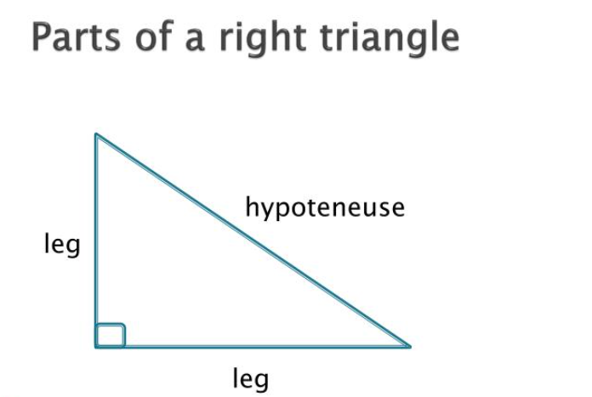
Level of Cognitive Complexity: | ☐ Creating  ☐ Evaluating  ☐ Analyzing | ☐ Applying  ☐ Understanding  ☐ Remembering
Key questions: | What is the relationship between the lengths of the sides of a right triangle?  How can the Pythagorean Theorem be used to find the missing side length of a right triangle?  How can the Pythagorean Theorem be used to solve real-life problems?
Closure: | Learning target questions will be discussed in the class at the end of the lesson. Students will have the chance to brainstorm and share ideas. Any misconceptions will be addressed at this time.
Next Steps: | We will use the proof lesson to explain and apply the Pythagorean Theorem.  Find real world examples for applying the Pythagorean Theorem and have students calculate the missing length:  - A garden  - A rope diagonally across an area  - Other areas at school/in classroom |  |  | Formative Assessment Criteria for Success:  Students will have a few guided practice problems that will be completed before students move on. During this guided practice, I will be able to check for understanding as I call on students to assist in solving the problems. After guided practice, students will practice independently as they complete task cards that will be posted around the room.

Examples for guided practice & task cards
