Date: |  |  | Duration of Lesson: 60 minute period
Title of Unit: Bivariate Numerical Data |  |  | Title of Lesson: Scatter Plots
Lesson Objectives: Students will be able to identify patterns in bi-variate data
Groupings (e.g., whole class, small groups, co-teaching): Whole class at the beginning and end, and partners in the middle of class
Skills & Standards: CCSS.MATH.CONTENT.8.SP.A.1
Construct and interpret scatter plots for bivariate measurement data to investigate patterns of association between two quantities. Describe patterns such as clustering, outliers, positive or negative association, linear association and nonlinear association.
Progression of Learning & Teaching
Opener: | I will take the class outside and tell them that we are going to collect some data about each person. Students will come up with activities that they want to measure, for example, a short sprint on the track, racing on the monkey bars, going across the balance beam, number of 3-point baskets shot, number of cartwheels completed, etc. I will also have them measure some non-active characteristics such as shoe size, height, wingspan, number of siblings, number of hours on social media, etc.  Before we go outside, I will tell them the goal for today and what we will be doing with the information that we obtain.  The lesson will start with the recording of data. Once we are back in the classroom, the lesson will start building on procedural fluency. The structure is a little different than students are used to because we will be going outside, and they usually do seat work before we move around the room, so we will be going in reverse order. |  |  | Points to Remember  - Materials:  - paper and writing utensils to gather data  - Tape measures  - Timers (cell phones)  - Graph paper  Goal of lesson is for students to be able to interpret data, the lesson is not about graphing ability. Gathering real-world relevant data is helpful for students to engage when interpreting scatter plots
Activities & Tasks: | Instructional Lesson:  - I Do: Some students may need help labeling their graphs and plotting points. I will review one on one with those students on how to plot points.  - Y’all Do:  - Students will work with a partner and select the data they want to graph. They will each graph the data and then compare their graphs.  - We Do: Facilitate a class discussion  - Students will share the information that they graphed. They will talk about how they labeled their graphs and any trends they may have seen while comparing the values of the ordered pairs. Struggling students can practice plotting with different ordered pairs and as a class we can discuss the best way to determine what units and spacing to go by.  - You Do:  - Independent practice may be needed for those struggling with plotting points. Homework is not needed at this time, as we will be spending a couple more days plotting data and discussing the relationships.  Activities/Tasks:  Collecting the data for their scatter plot, then constructing it and talking about the results  Once we are inside, I will have the students select two variables that they want to compare and I will have them create a graph, labeling each axis with one of the variables discuss at this time independent and dependent variable so that the students know which value to plot on X vs Y axis.  I will show a sample of how each person’s data can be represented by a coordinate that we will plot on the scatter plot. From there, I will let students complete their scatter plot. Once everyone has had time to graph, I will ask students to talk about anything that they notice on their graphs. Consider displaying Desmos results on screen for entire class discussion. There will be clusters and outliers that will be identified. Some may have trends depending on the –data they select. |  |  | Resources:  We will be using notebook paper to record the data. Each student will be responsible for recording students’ names and data. We will also be using graph paper to create the scatter plots.  Technology resource to differentiate: https://www.desmos.com/calculator  Students can plot points in Desmos and scatter plot will be done for them  Vocabulary:  Scatter Plots: graphs that present the relationship between two variables in a data-set. It represents data points on a two-dimensional plane or on a Cartesian system. The independent variable or attribute is plotted on the X-axis, while the dependent variable is plotted on the Y-axis.  Independent variable: the variable that is changed or controlled in a scientific experiment  Dependent variable: The variable being tested in an experiment  Bivariate Data: where each value of one of the variables is paired with a value of the other variable.  Clusters: data points that form distinct groups  Outliers: a data point that does not fit the pattern  Positive Trend: Data points will be going up when looking at scatter plot from left to right  Negative Trend: Data points will be going down when looking at a scatter plot from left to right  Example of scatter plot to share with students  Title, X & Y Axis are labeled, values on Axis  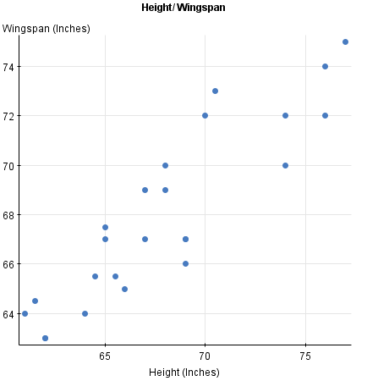  Monitoring/Scaffolding:  Some students may need to review how to plot points. Consider modeling for whole class how to label a graph appropriately. If using graphing software (desmos) demonstrate entering ordered pairs and labeling.  Consider limiting the number of data points to avoid excessive time spent on graphing.  Make sure that students are labeling the graphs correctly, including the title, x- and y- axis labeled, appropriate units used and spaced evenly. Provide technology OR premade graphs for students who struggle with fine motor skills or drawing to allow focus to be on interpreting data results rather than graphing mechanics
Level of Cognitive Complexity: | ☐ Creating  ☐ Evaluating  ☐ Analyzing | ☐ Applying  ☐ Understanding  ☐ Remembering
Key questions: | How can we represent this data?  What are some things that you notice about your scatter plot?
Closure: | Student will answer the question ‘ Why is it helpful to look at a graph when discussing data?’
Next Steps: | We will continue to create scatter plots from data, look at trends, and make predictions. |  |  | Formative Assessment Criteria for Success:  Students will construct their own scatter plot after we collect data. They will work with a partner, and I will check as they are constructing their graphs. After everyone has a completed their scatter plot, we will talk about what they notice and use the vocabulary to describe what they noticed.  The primary focus of the assessment criteria will be students’ interpretation about what they notice and wonder about the data

